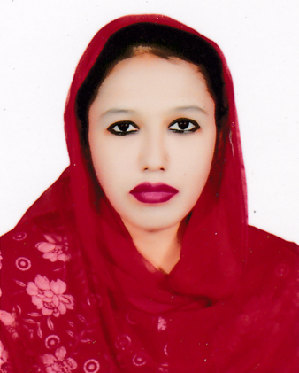**Jannatul Ferdous Khushi**

**House:** 152/1, Ahmed Nagar Paikpara

Mirpur-1, Dhaka-1216

**Mobile no:** 01554749674, 01998768948

**Email:** [lamiafarhakhan@gmail.com](mailto:lamiafarhakhan@gmail.com) , sister.khushi@gmail.com.

**Career Objective:**

* To achieve Professional excellence by putting efforts and exerting knowledge and skills, this will ultimately contribute to the achievement of personal and organizational goal.

**Educational Qualifications:**

* Evening **MBA (Dhaka University)**, at the department of International Business in the year of 2020, Obtaining CGPA 3.23 in the scale of 4.
* **BBA**, Major in Management from the department of Business Administration in Dhaka City College under National University in the year of 2015, Obtaining CGPA 3.36 in the scale of 4. ( Result published in 17th April, 2017)
* **HSC (Dhaka City College)**- 2011, obtaining GPA 4.80 in the scale of 5 from Business Studies Group, Dhaka Board.
* **SSC (Monipur High School)** - 2009, obtaining GPA 4.88 in the scale of 5 from Science Group, Dhaka Board.

**Language Skills:**

Good command over both Bengali and English Language

**Computer skills:**

Ms Office, Internet etc.

**Personal Details:**

**Father’s name**  : Khabir Uddin Sheikh

**Mother’s name**  : Kamrun Naher

**Mailing Address**  : House-152/1, Ahmed Nagar Paikpara,

Mirpur-1, Dhaka- 1216.

**Permanent Address**  : Village- Nawdapara,

Post office- Bheramara, District- kushtia.

**Date of Birth** : 28th December, 1994

**Nationality**  : Bangladeshi

**Marital Status**  : Single

**Religion**  : Islam

**References**

1. Md. Mansur Ali

Cell number- 01819019788

Assistant Professor, Department of Business Administration

Dhaka City College

1. Syeda Ferdous Lusanta

Cell number- 01712521993

Associate Professor, Department of Business Administration

Dhaka City College

**Declaration of Authenticity**

I declare hereby that all information I have presented so far are true to my Knowledge. If required and where applicable, this document can be supported by authentic certificate/papers.

Signature…khushi……………